 25 February 2026

Functionality Attestation (FA)

SUBJECT: Cisco Global Certification Team (GCT) Defense Programs (DP) Internal Compliance Review (ICR) Functionality Attestation (FA) of the Cisco Session Border Controller (SBC)
References:
(a) Defense of Defense Instruction (DoDI) 8100.04, “Department of Defense (DoD) Unified Capabilities (UC),” 09 December 2010
(b) Office of the DoD Chief Information Officer (CIO), “DoD Unified Capabilities Requirements 2013 (UCR 2013) Change 2,” September 2017
(c) Cisco GCT DP, “Cybersecurity Summary Report (CSR) for Cisco Session Border Controller (SBC), Software Rel. IOS XE 17.18”
(d) Test procedures

- Internal Compliance Authority. The Cisco GCT DP is designated as the attestation authority responsible for overseeing and validating the DTR process to ensure adherence to established Cybersecurity (CS) and FA standards.

- Conditions of Attestation. The Cisco SBC running Software Rel. Internetwork
Operating System (IOS) XE 17.18 (System Under Test, or SUT) has been attested for joint use and meets the essential High Availability (HA) SBC requirements outlined in the UCR 2013, Reference (b). This attestation remains valid under the condition listed
in Table 1 Conditions and will expire if any changes affecting interoperability are made, or on the date specified in the Cisco GCT DP DTR List.

Table 1. Conditions
TDR # | Description | Operational Impact | Remarks
None

- System Requirements identification and Test Configuration. The SUT, identified as the Cisco SBC with Software Rel. IOS XE 17.18 (detailed in Table 2-1), was tested by Cisco GCT DP. Figure 2-2 illustrates the SUT test configuration, including its components and connectivity schemes, which were consistently employed for both FA and CS testing.
Table 2-1. System Requirements Identification
System Identification
System Name | Cisco SBC
Increment and/or Version | IOS XE 17.18
Product Category | SBC with High Availability
Cisco Point of Contact
Tracking
DTR ID | Initial (ISR 4000 Series, ASR 1000 Series, C8000v, and C8000 Series)
Requirement Source
Unified Capabilities Requirement | UCR 2013, Change 2, Sections 2, 4, and 5
Remarks | None
Test Organization | Cisco GCT DP

Figure 2-2. SUT Test Configuration

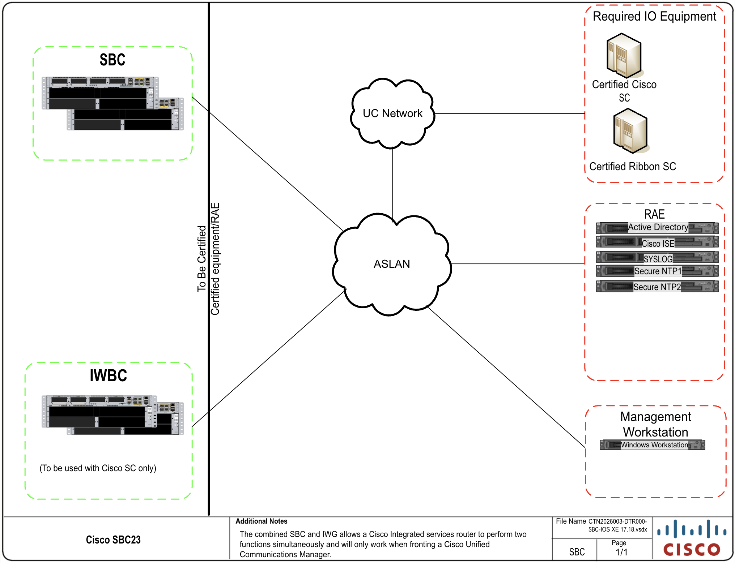

- System Description
  - General Description. The SUT is an SBC, which performs voice firewall and back-to-back user agent functions. The SBC consists of the voice or video firewall/border controller. The Call Connection Agent (CCA) in the Softswitch (SS) and Local Session Controller (LSC) needs to interact with Assured Services Session Initiation Protocol (AS-SIP) functions in the SBC which:

    - Mediates AS-SIP signaling between a Session Controller (SC) and a Wide Area Network (WAN) SS, and between two SSs.
    - Supports SBC functions, such as Network Address Translation (NAT) and Network Address and Port Translation (NAPT).
    - Supports Internet Protocol (IP) firewall functions.

SBCs can be attested in one of two availability categories: High Availability (HA) and Medium Availability. The SUT is attested for joint use as an HA SBC. The SUT supports IP firewall functions. The Cisco SBC facilitates IP to IP AS-SIP communications between SCs that support the Unified Capabilities Requirements (UCR) Alternative B failover method and their end instruments, when traversing the Unified Capabilities (UC) network. The SBC interfaces with Defense Information Systems Network (DISN) UC systems through an AS-SIP interface and provides IP to IP communications between edge LSC/Enterprise Session Controller (ESC) and core (Softswitch) segments in the UC network. Additional functions include AS-SIP signaling and encryption services to allow end to end communications on the UC network. This SBC solution consists of the Cisco Integrated Services Router (ISR) 4000 series, Aggregation Services Router (ASR) 1000 series, Catalyst (C)8000v, C8200 series, and C8300 series of hardware platforms.

The system consists of the following components:
- SBC
- Combined SBC/Interworking Gateway (IWBC)
- IWG (Interworking Gateway)

The SBC is an intelligent unified communications network border element that provides SBC functions that help enable end-to-end IP-based transport of voice, video, and data between independent unified communications networks and the UC network.

The SBC combined with IWG type deployment provides critical Session Initiation Protocol (SIP) message normalization functionality that allows for interoperability between components within the UC architecture for the Cisco SC. The combined SBC and IWG is an integrated Cisco IOS XE software application that runs on the Cisco ISR 4000 series, ASR 1000 series, C8000v, C8200 series, and C8300 series of hardware platforms.

  - Management Description. The SBCs are managed via SSHv2 on the management network or via a console cable with a terminal connection. Security and auditing can be performed through configuration to a Cisco Identity Services Engine (ISE) server or similar Site-Owned Remote Auxiliary Equipment (RAE) services that are integrated with Active Directory and syslog server to collect alarm and modification information of the system.

- Operational Architecture. The DoDIN architecture is structured as a two-level network hierarchy, comprising DISN backbone switches and Service/Agency installation switches. The specific type of switch permitted at any given location is determined by DoD Chief Information Officer and Joint Staff policy, along with subscriber mission requirements. Consequently, the DoDIN architecture incorporates various categories of switches. This notional operational DoDIN architecture, which illustrates where the SUT may be utilized, is depicted in Figure ES.1. UC High Level Operational Framework within the Department of Defense (DoD) Unified Capabilities Master Plan (UC MP).

- Test Details. This attestation is based on functionality testing. Cisco GCT DP conducted functionality testing from 01 February 2026 through 28 February 2026, using test procedures derived from Reference (d). Cisco is tracking on open TDRs found in Table 1. Cisco GCT DP conducted CS testing, with the results documented in a separate report (Reference (c)).

This is an initial request for IOS XE Release 17.18 software for product components Interworking Border Controller (IWBC), Interworking Gateway (IWG), and Session Border Controller (SBC). The request includes ASR 1006-X, Cisco Catalyst 8300 Series, Cisco Catalyst 8200 Series, ISR 4461/K9 and Cisco Catalyst 8000v Series.

- Functionality Status. Table 3 provides the SUT interface functionality status; Table 4 provides the SUT hardware, software and firmware versions; and Table 5 provides the Capability Requirements.
Table 3. SUT Interface Status
Network Management Interfaces
Interface | Applicability | Status | Remarks
IEEE 802.3i (10BaseT UTP) | Conditional(C) | Met | The SUT met the critical CRs and FRs for the IEEE 802.3i.
IEEE 802.3u (100BaseT UTP) | C | Met | The SUT met the critical CRs and FRs for the IEEE 802.3u.

Network Interfaces
Interface | Applicability | Status | Remarks
IEEE 802.3ab (1000BaseT UTP) | C | Met | The SUT met the critical CRs and FRs for the IEEE 802.3ab.
IEEE 802.3z (1000BaseX Fiber) | C | Met | The SUT does not support this interface.
IEEE 802.3ae (10GBaseX) | C | Met (See Note 2) | The SUT met the critical CRs and FRs for the IEEE 802.3ae.
IEEE 802.3an (10GBaseT UTP) | C | Met | The SUT met the critical CRs and FRs for the IEEE 802.3an.
IEEE 802.3ba (100GBaseX Fiber) | C | Not Tested | The SUT does not support this interface.
NOTE(S):
- Per the UCR, the SUT can support any one of these conditional interfaces. Table 3 depicts the SUT high-level requirements category and the applicability of each sub-requirement.
- The 10GBaseX WAN interfaces were not tested but are included and attested for joint use on only the 4000 Series and 8300 Series. IWBCs based on Cisco GCT DP’s ICR analysis of CER test data

Table 4. SUT Hardware/Software/Firmware Version Identification

Product Identification
Product Name | Cisco SBC
Software Release | IOS XE 17.18
UCR Product Type(s) | SBC
Product Description | The SBC is an intelligent unified communications network border element that provides SC functions that help enable end-to-end IP-based transport of voice, video, and data between independent unified communications networks and the DoDIN network. The Cisco SBC combined with IWG type deployment provides critical SIP message normalization functionality that allows for interoperability defined in the UCR change 2. The combined SBC and IWG is an integrated Cisco IOS XE software application that runs on the Cisco ISR 4000 series, ASR 1000 series, C8000v, C8200 series, and C8300 series of hardware platforms.
Product Components | Component Name  (See notes 1 and 2.) | Sub-Component | Tested Version | Function
IWBC | ASR1006-X | NA | IOS XE 17.18 | Provides connectivity to AS-SIP trunks. (See note 1.)
IWBC | C8200-1N-4T | NA | IOS XE 17.18 | Provides connectivity to AS-SIP trunks. (See note 1.)
IWBC | C8200L-1N-4T | NA | IOS XE 17.18 | Provides connectivity to AS-SIP trunks. (See note 1.)
IWBC | C8300-1N1S-4T2X | NA | IOS XE 17.18 | Provides connectivity to AS-SIP trunks. (See note 1.)
IWBC | C8300-2N2S-4T2X | NA | IOS XE 17.18 | Provides connectivity to AS-SIP trunks. (See note 1.)

Product Components | Component Name  (See notes 1 and 2.) | Sub-Component | Tested Version | Function
IWBC | C8300-1N1S-6T | NA | IOS XE 17.18 | Provides connectivity to AS-SIP trunks. (See note 1.)
IWBC | C8300-2N2S-6T | NA | IOS XE 17.18 | Provides connectivity to AS-SIP trunks. (See note 1.)
IWBC | C8000v | ESXi Server Host | IOS XE 17.18 | Provides connectivity to AS-SIP trunks. (See note 1.)
IWBC | ISR 4461/K9 | NA | IOS XE 17.18 | Provides connectivity to AS-SIP trunks. (See note 1.)
SBC | ASR1006-X | NA | IOS XE 17.18 | Provides connectivity to AS-SIP trunks. (See note 1.)
SBC | C8200-1N-4T | NA | IOS XE 17.18 | Provides connectivity to AS-SIP trunks. (See note 1.)
SBC | C8200L-1N-4T | NA | IOS XE 17.18 | Provides connectivity to AS-SIP trunks. (See note 1.)
SBC | C8300-1N1S-4T2X | NA | IOS XE 17.18 | Provides connectivity to AS-SIP trunks. (See note 1.)
SBC | C8300-2N2S-4T2X | NA | IOS XE 17.18 | Provides connectivity to AS-SIP trunks. (See note 1.)
SBC | C8300-1N1S-6T | NA | IOS XE 17.18 | Provides connectivity to AS-SIP trunks. (See note 1.)
SBC | C8300-2N2S-6T | NA | IOS XE 17.18 | Provides connectivity to AS-SIP trunks. (See note 1.)
SBC | C8000v | ESXi Server Host | IOS XE 17.18 | Provides connectivity to AS-SIP trunks. (See note 1.)
SBC | ISR 4461/K9 | NA | IOS XE 17.18 | Provides connectivity to AS-SIP trunks. (See note 1.)
IWG | ASR1006-X | NA | IOS XE 17.18 | Provides connectivity to AS-SIP trunks. (See note 1.)
IWG | C8200-1N-4T | NA | IOS XE 17.18 | Provides connectivity to AS-SIP trunks. (See note 1.)
IWG | C8200L-1N-4T | NA | IOS XE 17.18 | Provides connectivity to AS-SIP trunks. (See note 1.)
IWG | C8300-1N1S-4T2X | NA | IOS XE 17.18 | Provides connectivity to AS-SIP trunks. (See note 1.)
IWG | C8300-2N2S-4T2X | NA | IOS XE 17.18 | Provides connectivity to AS-SIP trunks. (See note 1.)

Product Components | Component Name  (See notes 1 and 2.) | Sub-Component | Tested Version | Function
IWG | C8300-1N1S-6T | NA | IOS XE 17.18 | Provides connectivity to AS-SIP trunks. (See note 1.)
IWG | C8300-2N2S-6T | NA | IOS XE 17.18 | Provides connectivity to AS-SIP trunks. (See note 1.)
IWG | C8000v | ESXi Server Host | IOS XE 17.18 | Provides connectivity to AS-SIP trunks. (See note 1.)
IWG | ISR 4461/K9 | NA | IOS XE 17.18 | Provides connectivity to AS-SIP trunks. (See note 1.)
IWBC, IWG, SBC | ESXi Server Host | NA | ESXi 8.0.3, 2402251
IWBC, IWG, SBC | Management Workstation  (Site-provided) | NA | Windows 11  Enterprise, v22H2
IWBC, IWG, SBC | Management Workstation  (Site-provided) | NA | ActivClient 7.3.0.25
IWBC, IWG, SBC | Management Workstation  (Site-provided) | NA | Axway Desktop  Validator SE  5.0.30052
IWBC, IWG, SBC | Management Workstation  (Site-provided) | NA | SecureCRT v9.3.2  (x64 build 2978)
NOTE(S):
- The SUT was initially attested with Software Release IOS XE 17.18.
Cisco GCT DP tested the bolded and underlined components/sub-components. The remaining items in the family series were not directly tested but are attested for joint use because they share the same software and similar hardware as the tested components. Based on Cisco GCT DP's analysis, they are functionally identical for Functionality Attestation purposes.

Table 5. SUT Capability Requirements and Functional Requirements Status

CR/FR ID | UCR Requirement (High-Level) | A pplicability  (See note 1.) | UCR 2013  Change 2 | Status
1 | SC and SS Failover and Recovery | Required | 2.6 | Met (See note 2.)
 | SC Failover: Alternative A: The SC-Generated OPTIONS Method | Optional | 2.6.1 | Not Tested (See note 2.)
 | SC Failover: Alternative B: The SBC Generated OPTIONS Method | Required | 2.6.2 | Met (See note 2.)
2 | Product Interface | Required | 2.7 | Met
 | Internal Interfaces | Required | 2.7.1 | Met
 | External Interfaces | Required | 2.7.2 | Met
 | EMS Interfaces | Required | 2.7.4 | Met
3 | AS-SIP IP Gateway | Conditional | 2.11 | Met
 | AS-SIP IP Gateway Media Interworking | Conditional | 2.11.2 | Met
4 | Session Border Controller (SBC) Enterprise Session Controller (ESC) | Required | 2.12.4 | Met (See note 4.)
 | General SBC Functionality | Required | 2.12.4.1 | Met (See note 3.)
 | Enclave-Fronting SBC Functionality | Required | 2.12.4.2 | Met (See note 3.)
 | Enclave-Fronting SBC Functionality within the core infrastructure | Required | 2.12.4.3 | Met (See note 3.)
5 | Remote Media Gateway | Conditional | 2.16 | Met
 | Remote MG | Conditional | 2.16.13 | Met
6 | Session Border Controller | Required | 2.17 | Partially Met (See note 4.)
 | AS-SIP Back-to-Back User Agent | Required | 2.17.1 | Met
 | Call Processing Load | Required | 2.17.2 | Met
 | Network Management | Required | 2.17.3 | Met
 | DSCP Policing | Optional | 2.17.4 | Not Tested (See note 5.)
 | Codec Bandwidth Policing | Optional | 2.17.5 | Met
 | Availability | Required | 2.17.6 | Partially Met (See note 4.)
 | IEEE 802.1Q Support | Required | 2.17.7 | Met
 | Packet Transit Time | Required | 2.17.8 | Met
 | H.323 Support | Conditional | 2.17.9 | Met
 | SBC Requirements to Support Remote MG | Conditional | 2.17.10 | Met
 | SBC Support for Multiple SCs | Optional | 2.17.11 | Met
7 | Network Management | Required | 2.19 | Met (See note 6.)
 | General Management | Required | 2.19.1 | Met
 | Requirements for FCAPS Management | Required | 2.19.2 | Met (See note 4.)
8 | Cybersecurity | Required | 4.2 | Met (See note 6.)
9 | Internet Protocol version 6 | Required | Table 5.2-1 | Met
10 | AS-SIP 2013 | Required | AS-SIP | Met
NOTE(S):
- The annotation of ‘required’ refers to a high-level requirement and applicability of each sub-requirement. Refer to the UCR 2013, Change 2 (b).
- The UCR states that each SC and SBC pairing shall support OPTIONS-based failover by at least one of the following methods.
1. Alternative A: The SC-Generated OPTIONS Method or
2. Alternative B: The SBC-Generated OPTIONS Method. The SUT supports Alternative B SBC-
Generated OPTIONS Method for failover.
- This requirement applies specifically to an SBC fronting an ESC.
- The SUT met the requirements for High and Medium Availability with testing and the Vendor’s LoC, with the following exception, documented in Table 1: MLPP calls fail to produce audio upon preemption.
- The SUT does not support the optional DSCP Policing requirement.
- A GCT DP test conducted CS testing and published the results in a separate report, Reference (c). In addition to the CS testing conducted by the test team, the SUT met the requirements in section 4 with the (GCT DP) Vendor’s LoC.

- Point of Contact (POC): Cisco Global Certification Team, Defense Programs
7025-2 Kit Creek Road, Research Triangle Park, North Carolina 27709
Cisco GCT DP Email: gct-dp-icr@cisco.com

List of Acronyms
Acronym List
ASR | Aggregation Services Router
AS-SIP | Assured Services Session Initiation Protocol
APL | Approved Products List
BaseT | Megabit (Baseband Operation, Twisted Pair) Ethernet
BaseX | Megabit Ethernet over Fiber or Copper
C | Catalyst
CAC | Common Access Card
CAR | Cybersecurity Assessment Report
CCA | Call Connection Agent
CER | Customer Edge Router
CR | Capability Requirement
CIO | Chief Information Officer
CS | Cybersecurity
DISN | Defense Information Systems Network
DoD | Department of Defense
DODI | Department of Defense Instruction
DODIN | Department of Defense Information Network
DP | Defense Programs
DTR | Desktop Review
ESC | Enterprise Session Controller
ESXi | Elastic Sky X integrated
FR | Functional Requirement
GBaseT | Gigabit Ethernet over Copper
GBaseX | Gigabit Ethernet over Fiber or Copper
GCT | Global Certification Team
HA | High Availability
ICR | Internal Compliance Review
IEEE | Institute of Electrical and Electronic Engineer
ID | Identification
IOS XE | Internetwork Operating System XE
IP | Internet Protocol
ISR | Integrated Service Router
IWBC | Interworking Border Controller
IWG | Interworking Gateway
LoC | Letter of Compliance
LSC | Local Session Controller
MLPP | Multilevel Precedence and Preemption
NAT | Network Address Translation
NAPT | Network Address and Port Translation
R | Required
Rel. | Release
SBC | Session Border Controller
SC | Session Controller
SIP | Session Initiation Protocol
SS | Softswitch
STIG | Security Technical Implementation Guideline
SUT | System Under Test
UC | Unified Capabilities
UC MP | Unified Capabilities Master Plan
UCR | Unified Capabilities Requirements
UTP | Unshielded Twisted Pair
WAN | Wide Area Network

